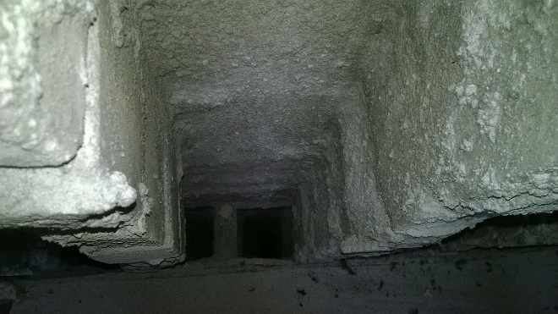

(The above picture will be replaced according to the visit site)

**Group name**

*First name, Last name; First name, Last name; First name, Last name; First name, Last name; First name, Last name*

Visiting place: ________

Visiting data: xx. xx 2022. Submission date: xx. xx 2022.

**Please name your final report document (docx, pptx, pdf) as follow: groupName_report_dd-mm-yyyy.**

**For example: Aging_RepairWork_26112021.docx**

**Aging_Presentation_26112021.pptx**

Every section of this project is finished by every member, and every one burden the same workload on each section.

Yes, every section is finished by all students in our group.

No, we divided the project into different parts. One student is responsible for 1~2 sections only.

Contents

1 Abstract (Approx 200 words) 3

1.1 Summary of the report 3

1.2 Contribution to the report 3

2 Implemented repair methods vs. the planned repair methods 3

2.1 Subtitle 1 (if applicable) 3

2.2 Subtitle 2 (if applicable) 3

3 The used repair materials, devices, tools 3

3.1 Subtitle 1 (if applicable) 3

3.2 Subtitle 2 (if applicable) 3

4 Sustainability in renovation work 3

4.1 Subtitle 1 (if applicable) 3

4.2 Subtitle 2 (if applicable) 3

5 load bearing capacity of repaired structures 3

5.1 Subtitle 1 (if applicable) 3

5.2 Subtitle 2 (if applicable) 4

6 Safety measures for repair work 4

6.1 Subtitle 1 (if applicable) 4

6.2 Subtitle 2 (if applicable) 4

7 SWOT-analysis (Strengths, Weaknesses, Opportunities, Threats) 4

7.1 Subtitle 1 (if applicable) 4

7.2 Subtitle 2 (if applicable) 4

8 Estimation of the residual service life of repaired structures 4

8.1 Systematic durability planning 4

8.2 Service life evaluation of the repaired structure 4

8.3 Subtitle 3 (if applicable) 4

9 Quality Specifications for the Repair Action to Ensure the Target Service Life 4

9.1 Subtitle 1 (if applicable) 4

9.2 Subtitle 2 (if applicable) 5

10 Discussion 5

10.1 Subtitle 1 (if applicable) 5

10.2 Subtitle 2 (if applicable) 5

11 Conclusion and Recommendations 5

12 References 5

13 Appendices 5

# Abstract (Approx 200 words)

## Summary of the report

## Contribution to the report

(Provide details of the group members and their area (contribution) of the investigation. If every one contributes equally, please leave this blank.)

# Implemented repair methods vs. the planned repair methods

## Subtitle 1 (if applicable)

## Subtitle 2 (if applicable)

# The used repair materials, devices, tools

## Subtitle 1 (if applicable)

## Subtitle 2 (if applicable)

# Sustainability in renovation work

## Subtitle 1 (if applicable)

## Subtitle 2 (if applicable)

# load bearing capacity of repaired structures

## Subtitle 1 (if applicable)

## Subtitle 2 (if applicable)

# Safety measures for repair work

## Subtitle 1 (if applicable)

## Subtitle 2 (if applicable)

# SWOT-analysis (Strengths, Weaknesses, Opportunities, Threats)

## Subtitle 1 (if applicable)

## Subtitle 2 (if applicable)

# Estimation of the residual service life of repaired structures

## Systematic durability planning

Example of the systematic durability planning is shown below:

|  |  |  |  |  |
| --- | --- | --- | --- | --- |
| **Potential deterioration mechanism** | **Environmental factors / Exposure classes** | **Properties of materials** | **Properties of structure** | **Required action to be taken** |
|  |  |  |  |  |

## Service life evaluation of the repaired structure

## Subtitle 3 (if applicable)

# Quality Specifications for the Repair Action to Ensure the Target Service Life

## Subtitle 1 (if applicable)

## Subtitle 2 (if applicable)

# Discussion

## Subtitle 1 (if applicable)

## Subtitle 2 (if applicable)

# Conclusion and Recommendations

# References

[1] Pandey, A. K., M. Biswas, and M. M. Samman. "Damage detection from changes in curvature mode shapes." Journal of sound and vibration 145.2 (1991): 321-332. (example)

*Reference management software is recommended (for example Mendeley, Endnote, Zotero, etc.).*

# Appendices

Interviews, site notes, including pencil/pen sketches with notations/comments, notes of group meetings and other relevant information.